Lighting Model for King Kong (Xenon)

The rendering engine being redesigned for the Xenon version of King Kong requires us to define a lighting model which we present here. We expect this lighting model to be used globally on every object rendered in the scene. After some discussion we came up with this lighting equation:

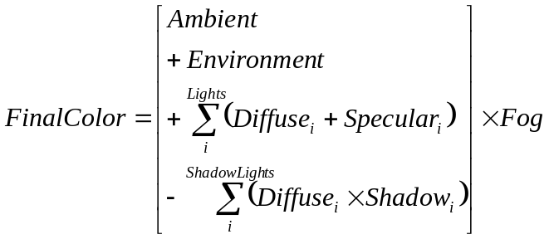

Definition of terms:

Ambient

A combination of global static colour predefined by an artist or a dynamic colour managed by some AI zoning system and pre-computed diffuse lighting. The equation is the following:

- AmbientFactor: Global ambient color as defined in the world.
- WorldAmbient: Percentage of the ambient component to use (Global).
- RLIFactor: Percentage of the RLI component to use (Global).
- VertexRLI: RLI color of the current vertex.
- VertexPaintFactor: Percentage of the Vertex paint component to use (Default 1.0f, not editable for now).
- VertexPaint: Vertex paint color of the current vertex.
- DiffuseMap: Base texture.

Diffuse

The equation for the diffuse component is the following:

It can be computed on a per-vertex or a per-pixel basis.

- MaterialDiffuse: Diffuse color of the material.
- LightDiffuse: Diffuse color of the light.
- Attenuation: Attenuation factor, distance based.
- DiffuseMap: Base texture.

Specular

The specular colour is always calculated dynamically because it depends on the camera view vector. It too, can be computed in two manners, depending on whether we want it per vertex or per pixel. Typically, per-pixel diffuse and per-pixel specular are used in conjunction since they can be calculated in the same step. We will use the following equation:

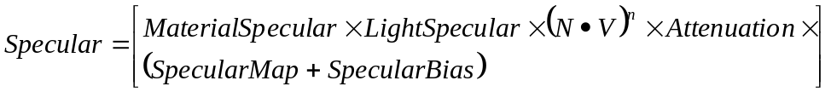

- MaterialSpecular: Specular color of the material.
- LightSpecular: Specular color of the light.
- Attenuation: Attenuation factor, distance base.
- SpecularMap: Specular mask texture.
- SpecularBias: Specular bias.

Reflection

The reflection term is also stored in a texture. This texture is also computed dynamically every frame as it depends on the camera position and direction.

Fog

A global static colour predefined by an artist or a dynamic colour managed by some AI zoning system. However this colour varies at each pixel according to a fog factor based on the pixel’s depth.

Shadow

The shadow term comes from a shadowmap associated with the current light. The shadowmap is a texture dynamically computed (every frame) in a separate pass that renders from the point of view of the light. It stores depth information for each pixel.

Since we are using a different set of lights to cast shadows, we treat them as normal lights with an inverse contribution. It means that a shadow light will actually remove light intensity from the scene in the regions affected by shadows.

Pixel shader requirements

SC: TODO: UPDATE.

The above equation contains a summation as one of its terms. The summation represents the accumulation of n lights.

Each light requires a separate set of the following:

Diffuse: 1 texcoord for diffuse texture
Normal map: 3 texcoords (light dir, halfway vector, attenuation). Normalization cube map not needed because there is now a “normalize” PS instruction.
Shadow: 1 texcoord

Because we plan to support several lights and we have a limited number of texcoord registers in the pixel shader, it seems we will have no choice but to do a rendering pass for every light that affects the current frame.

The gloss map and normal map textures use the same texcoord as the diffuse one. Therefore, 5 texcoord registers are needed per light. This forces a multi-pass approach.

At this time, we are targeting 8 lights per frame. We reserve the right to increase or decrease that number as empirical data on typical scenes is gathered.

